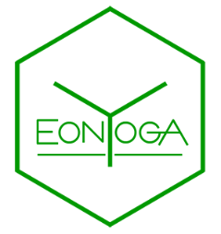
APPLICATION FORM 2021

Full names:
Email Address:
Contact:
Physical Address:
Date of Birth:
Please provide a summary of your yoga history:
Overview:

What style of yoga do you practice?
Do you have a self-practice?
If so, what does it consist of?

Can you perform the following asanas: (Y/N)
Ardha Chandrasana/ Half-moon:
Bakasana/ Crane posture:
Chaturanga Dandasana/Rod (low plank):
Padmasana/Full Lotus:
Urdhva Dhanurasana/Backbend, pushing up from the floor:
Ustrasana/ Camel pose:
Virabhadrasana 3/ Warrior 3:
Sirsasana/ Headstand:
Salamba Sarvangasana/Shoulder stand:

Other relevant information:
Do you have any injuries?
If yes, specify:

Do you have any chronic disease?
If yes, specify:

List any medication you are currently taking:
Do you practice pranayama (breathing techniques)?
If yes, specify:
Do you meditate?
Please give details on frequency and duration:

How does yoga form part of your life and what might be some of the areas that you wish to improve upon?

Where would you like to see yourself regarding your practice and teaching once you have completed the 200-hour course?

_________________________________________________________________________________
*You will be required to attend a yoga session with one of the Eonyoga assistants for physical assessment.
*To book an assessment class email us at hello@eonyoga.com
*Eonyoga will contact you to confirm whether you have been accepted for the Level 1 RYT 200 teacher training course.
*Payment only to be made after confirmation of acceptance by Eonyoga teacher training school.
*Please note that the individual, and not Eonyoga, will be responsible for incurring the costs of any online banking transactions should it be deemed necessary.
*A minimum of 5 students required for the course to commence.
__________________________________________________________________________________

. . . . . . . . . . . . . . . . . . . . . . . . . . . . . . . . . . . . . . . . . . . . .
Name Signed Date

